**TEST PROTOCOL**

**DVT Buffer**

**Performance measurements**

|  |  |  |
| --- | --- | --- |
| **Version** | **Date** | **Created**  **by / at** |
| **1.00** | **2016-05-24** | **S.Kulik**  **2016-05-24** |

# Test arrangement

Schematic

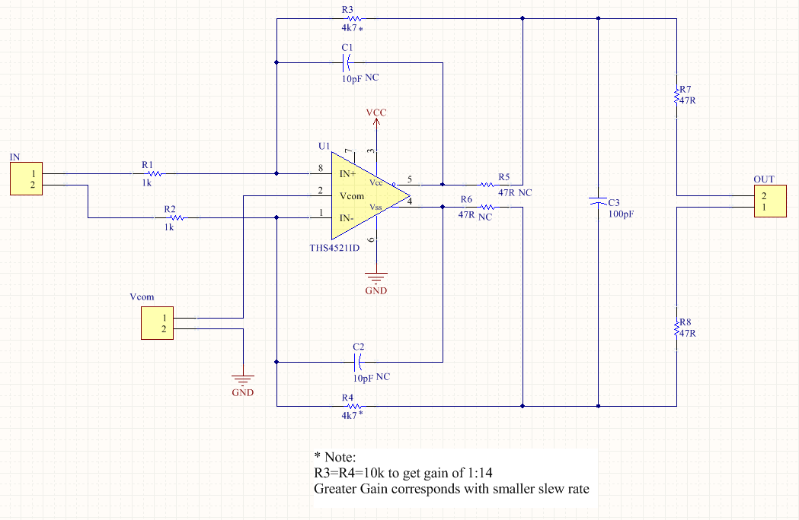

Gain set to 1:14, overall bandwidth will not limited ( C1, C2, R6 and R5 not used).

3.3Vdc used as power supply for all tests.

On Vcom connector soldered 100nF ceramic capacitor to stabilize the common mode performance.

EN Pin7 is not used to disable power-down feature.

As input used 1:1 transformer connected to single –ended function generator output one side and on IN-connector at other side.

1.4

1.3

2.5

2.2

2.4

## Testing configuration

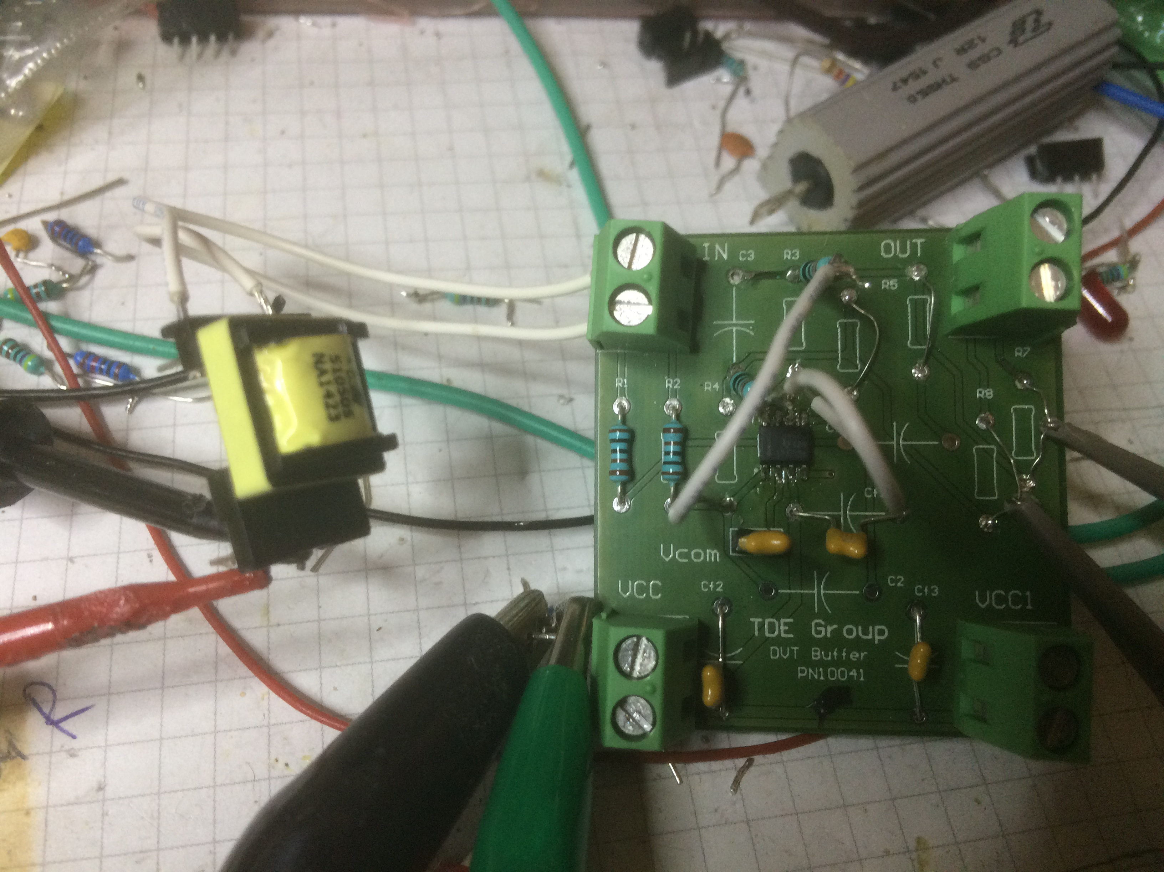

Testing

Probes

Power

Supply

Input

transformer

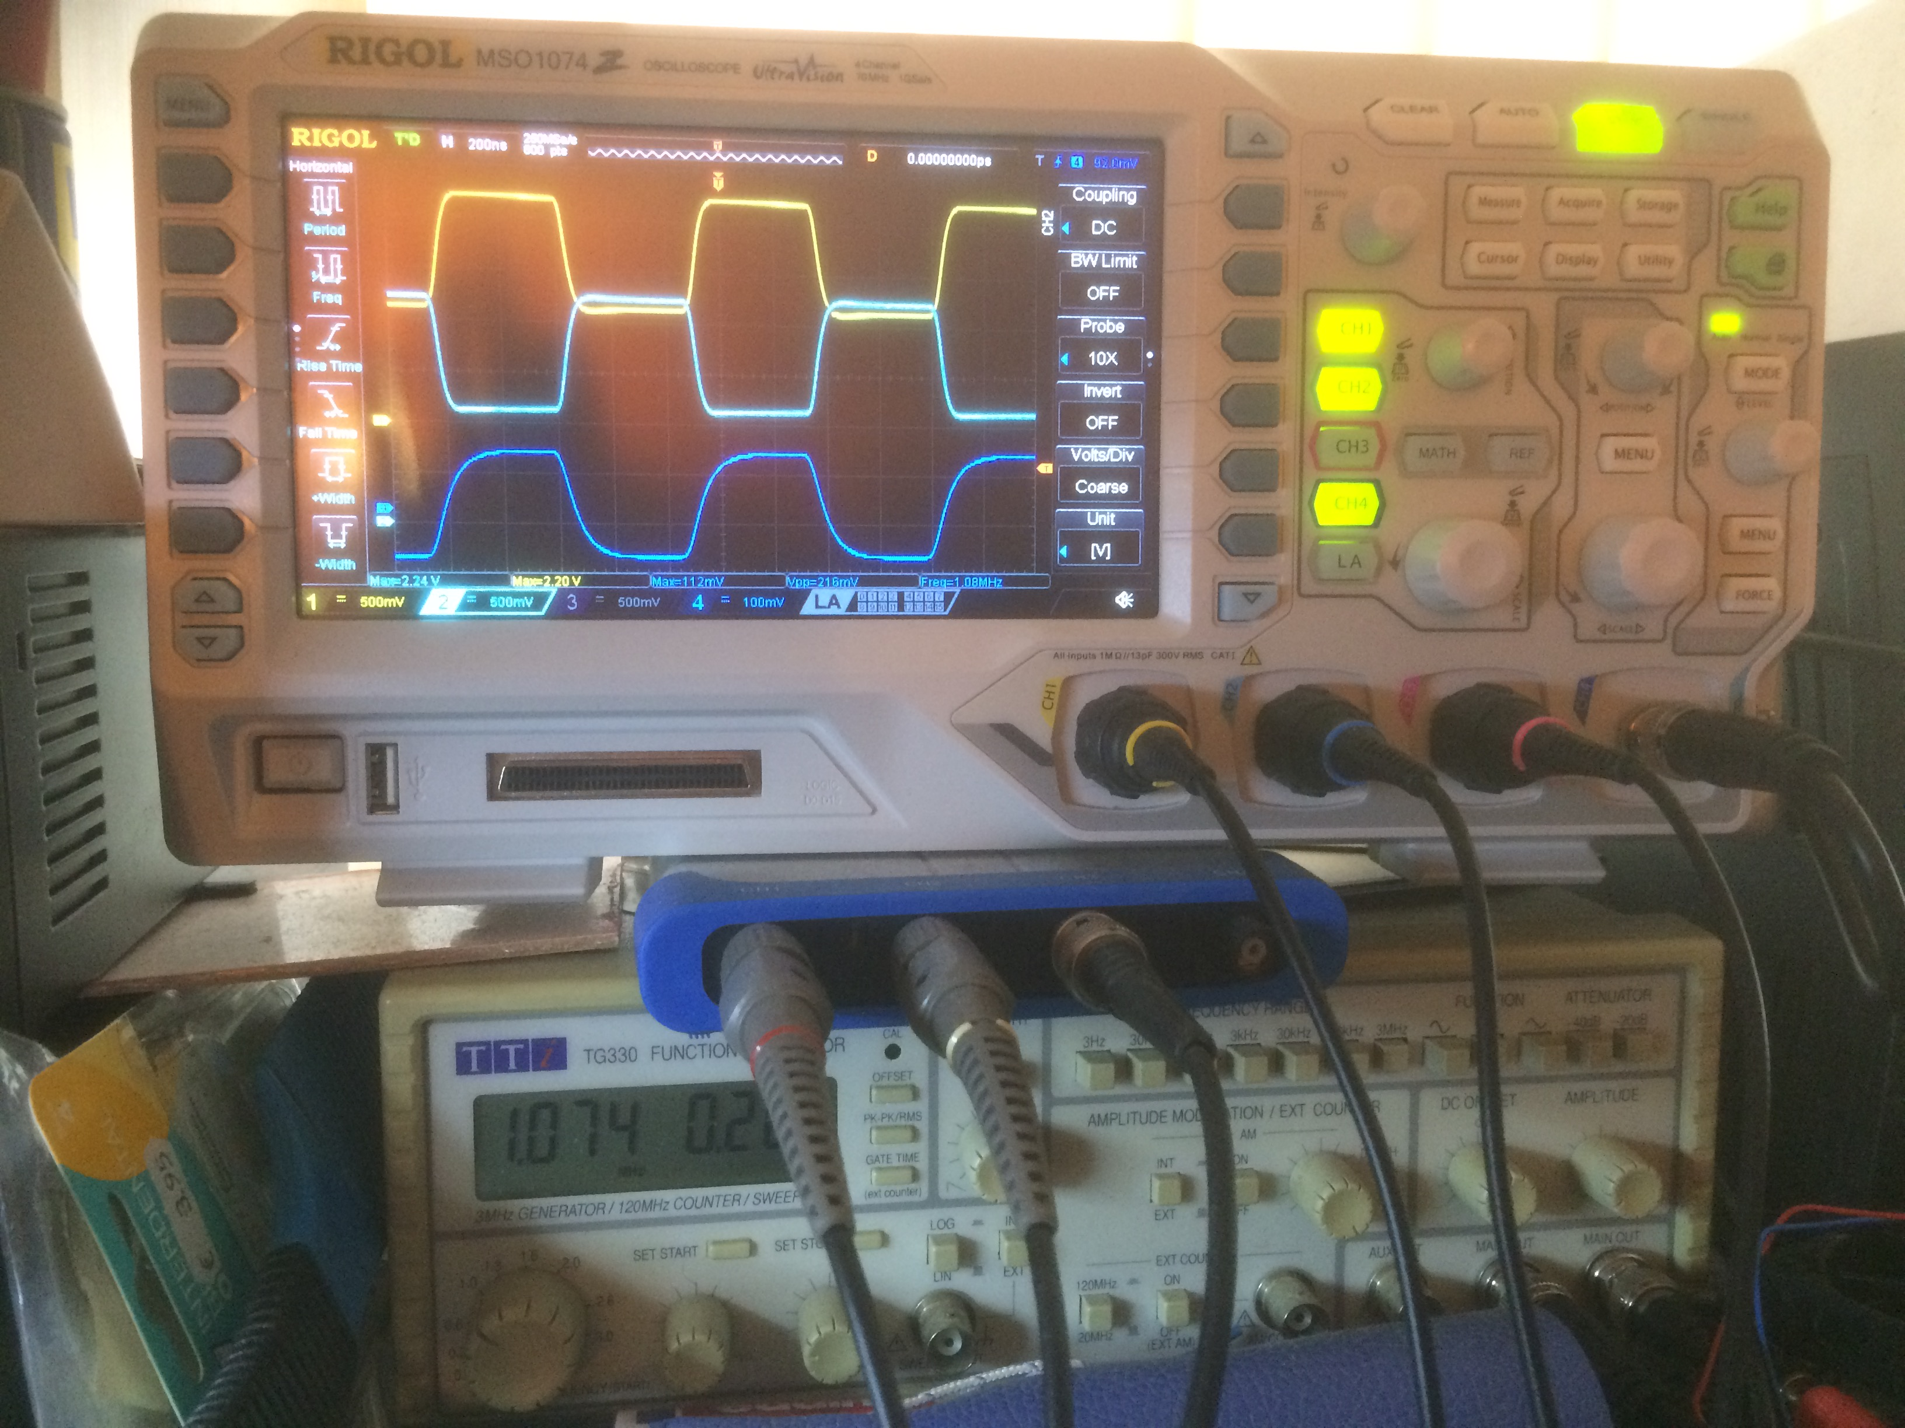

Measurement results

Legend: Yellow= Output+ , Cyan= Output- , Blue= Input (Generator)

**100kHz**

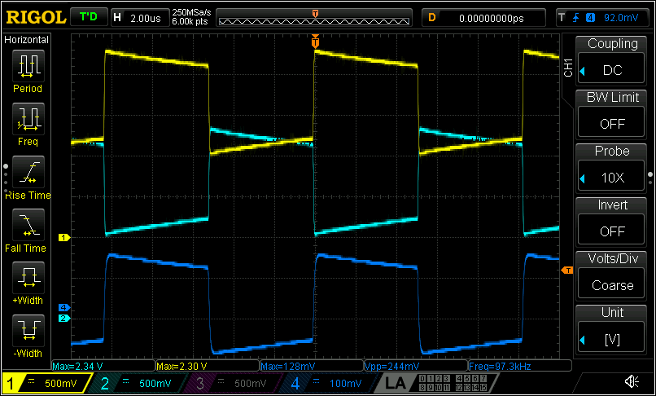

200kHz

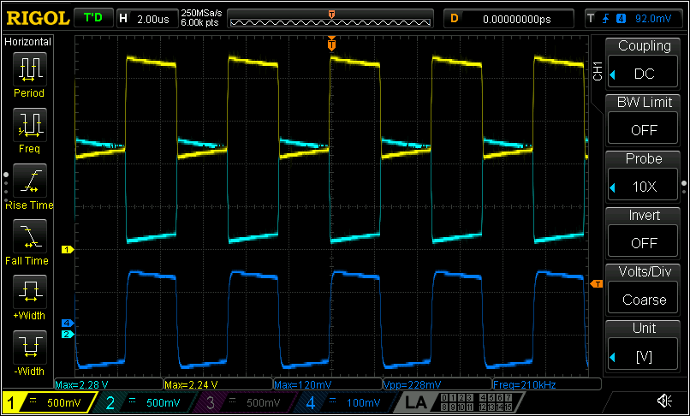

Hz

**400kHz**

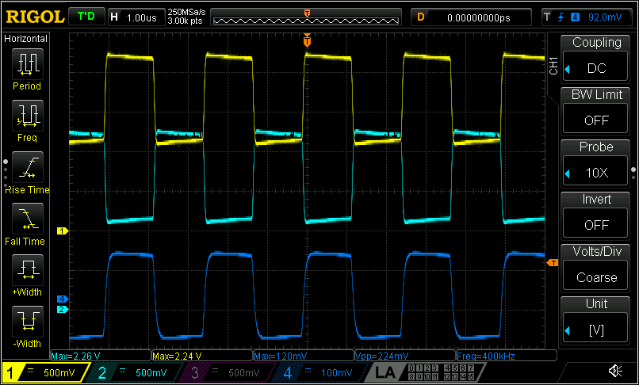

**600kHz  
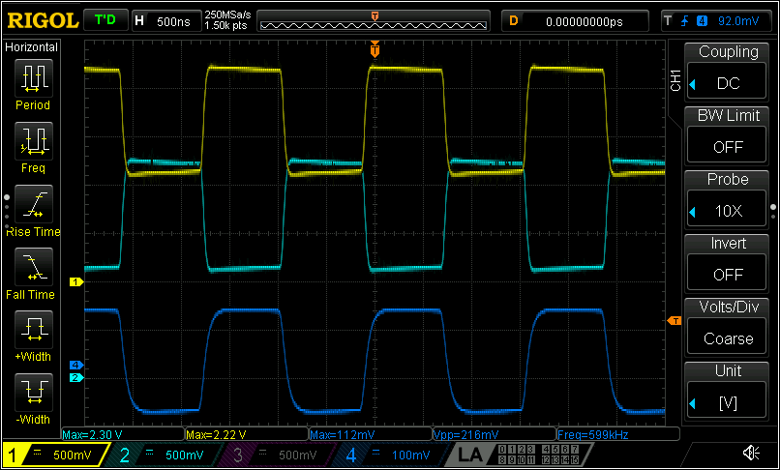**

800kHz

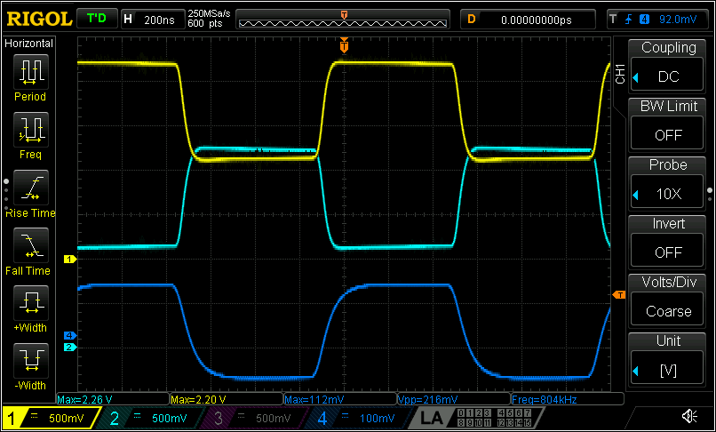

1MHz

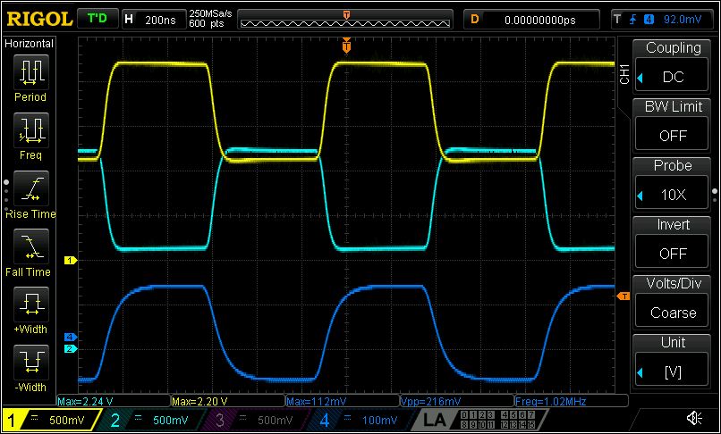

1.2MHz

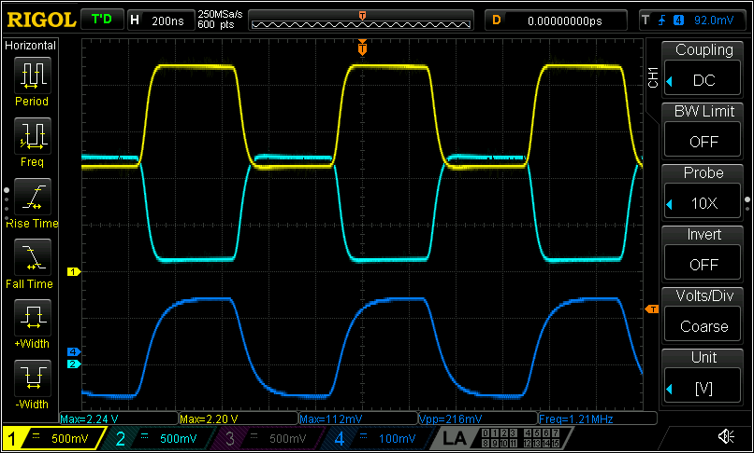

1.4MHz

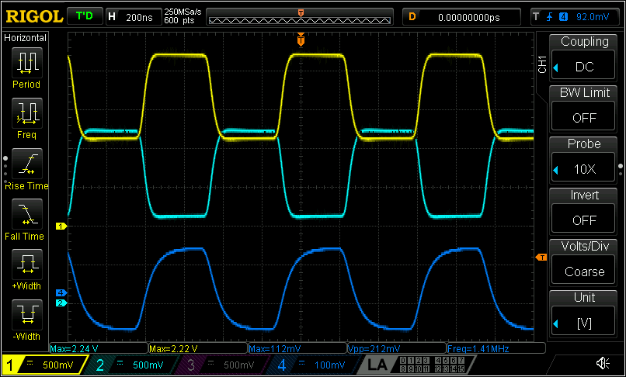

1.6MHz

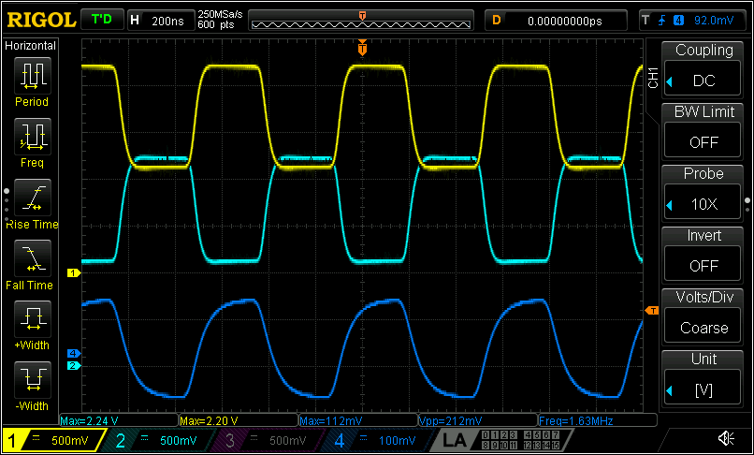

**1.8MHz**

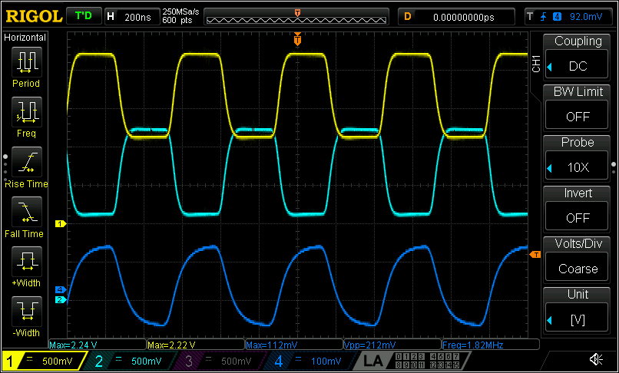

**2MHz**

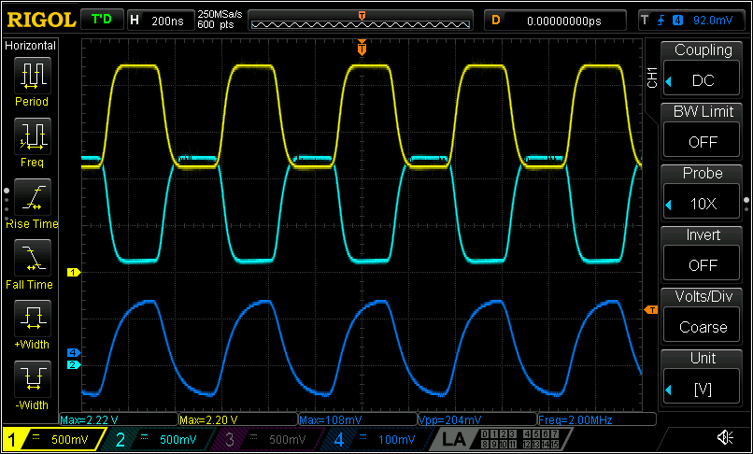

**2.2MHz**

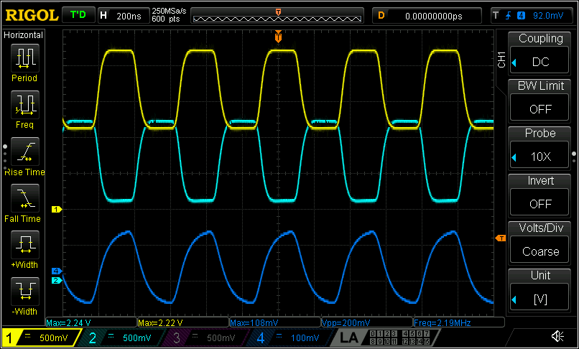

**2.4MHz**

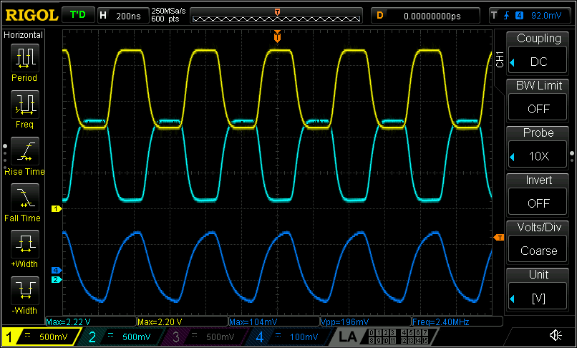

**2.6MHz**

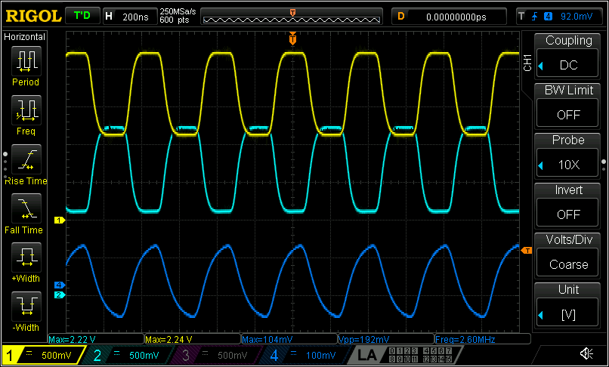

**2.8MHz**

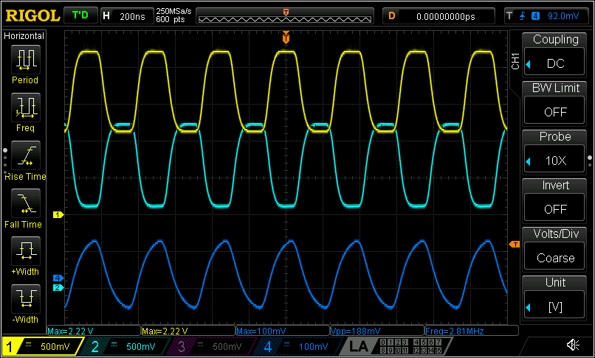

**3MHz**

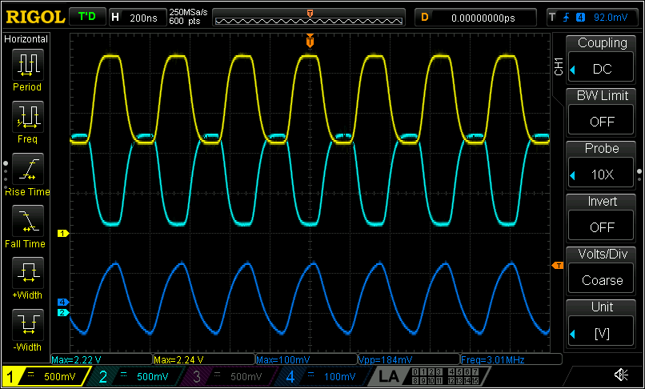

**Summary**

THS4521 device is highly recommend for our application as fully differential OP with impressive performance.

## Summary

The resistance of the contact pins with contact socket can be reduced by polishing the contact surface, furthermore a gold or silver coating should be tested!  
For isolation values we can say that only the pins from company “HS-Technik” performed well, even after 500 mechanical connections.  
Pins from “HKAA” have major issues with the coating and the clamping force of the sockets should be increased to tighten the connection and reduce the resistance.